Assignment-4

|  |  |
| --- | --- |
| **Student Name** | Nagaarthi P |
| **Student Roll Number** | 510419106016 |
| **Maximum marks** | 2marks |

**TASK 2:**

Create a docker file for the job portal application and deploy it in Docker Desktop Application

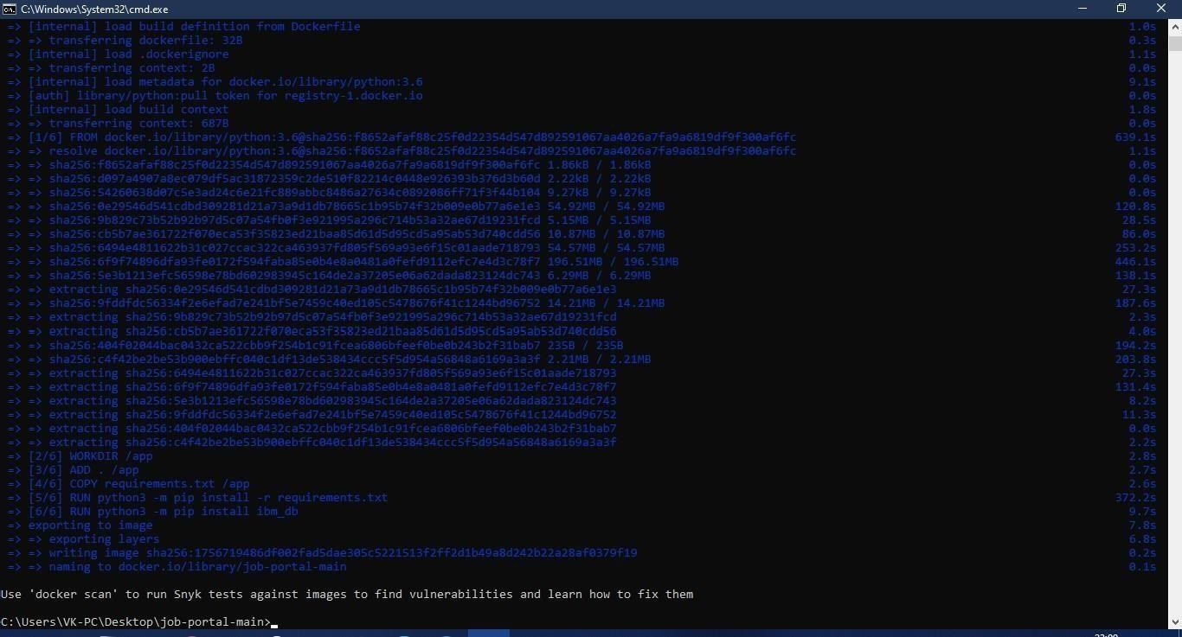

FROM helloworld:latest WORKDIR ~/Desktop/ ADD . helloworld/

WORKDIR ~/Desktop/htmlfile RUN pip install -r requirements RUN chmod +x app.sh

CMD ["/bi n/sh","app.sh"]